1 . Create a S3 bucket and enable cross region replication for any two buckets in different in different region ?

* Go to Amazon S3 , Click on Create Bucket

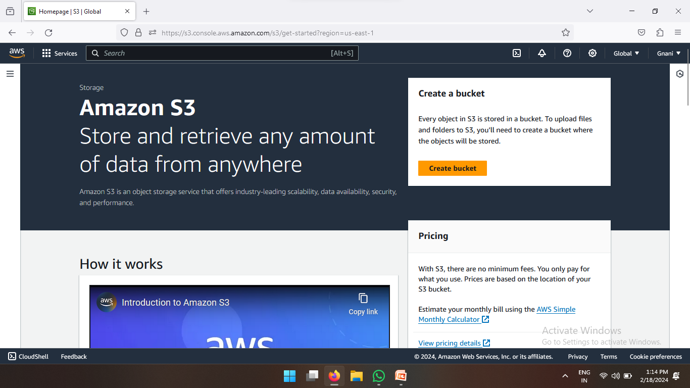

* Enter Bucket Name and Select Any one Region

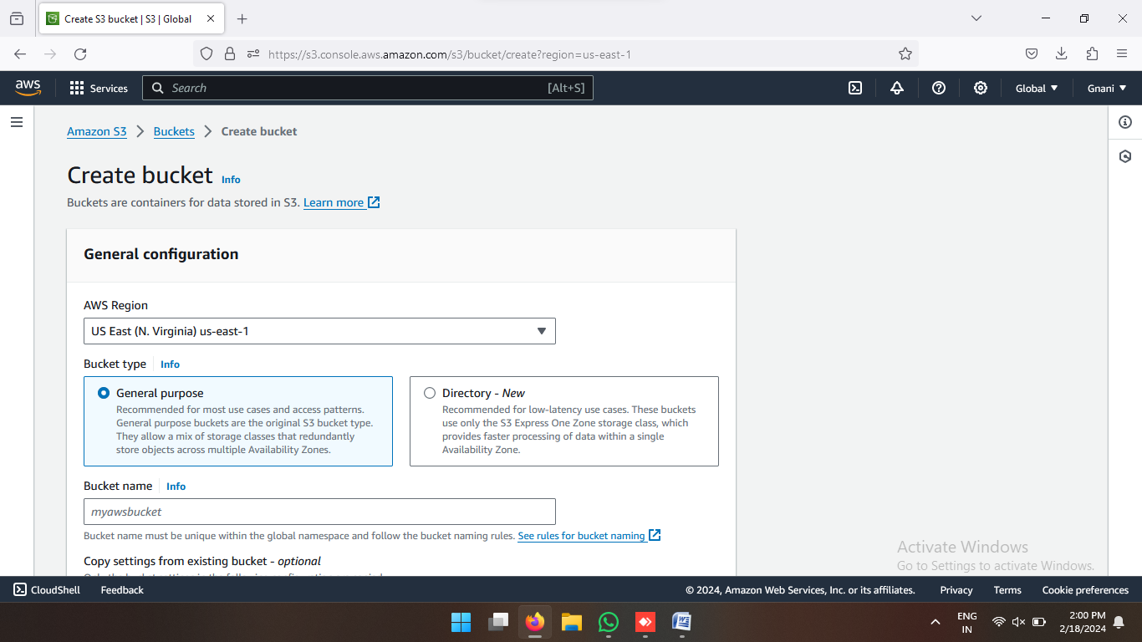

* Enable Bucket Version

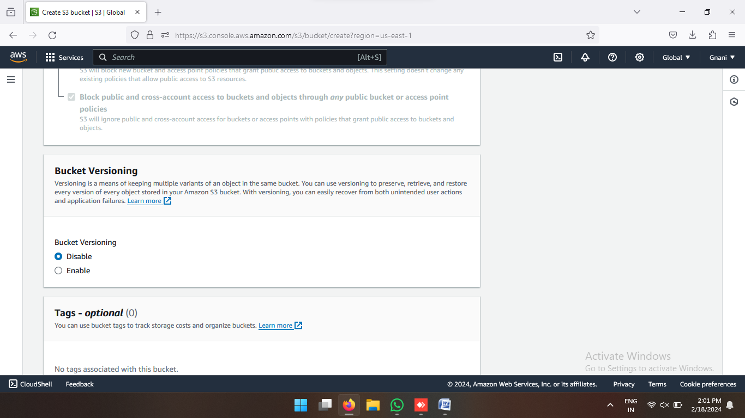

* After that Click on Create Bucket

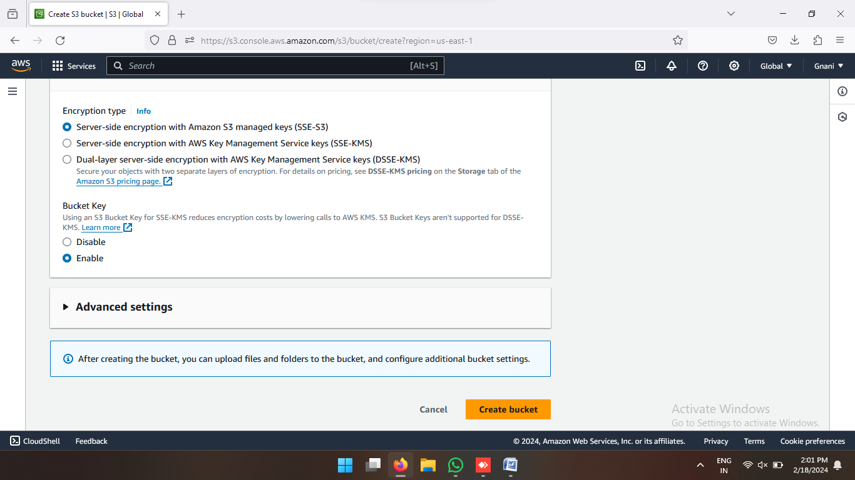

* One more bucket created in different region.

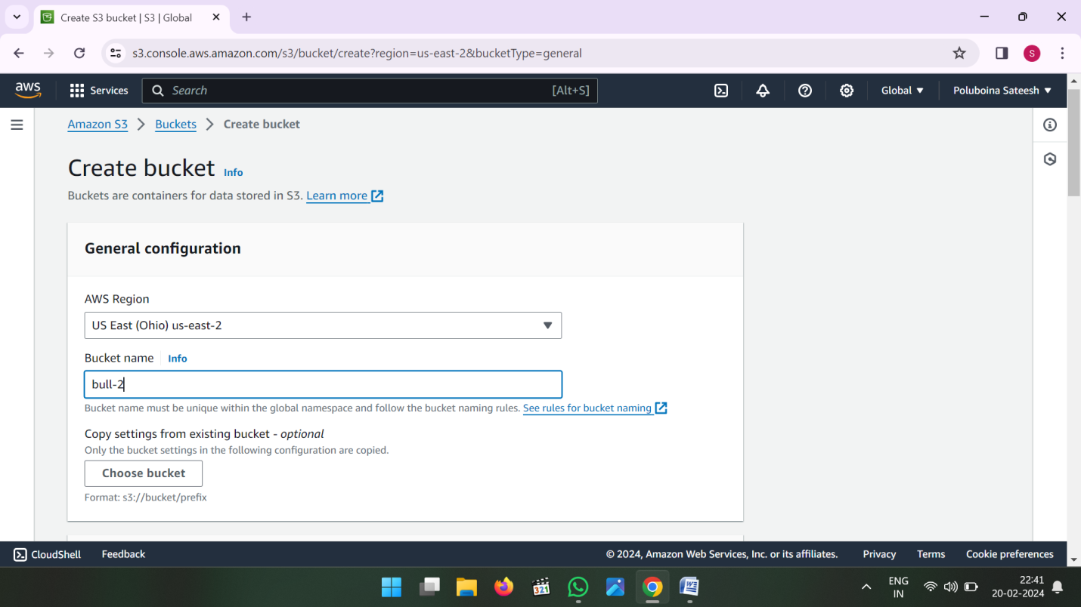

Now see the 2 Buckets in different region

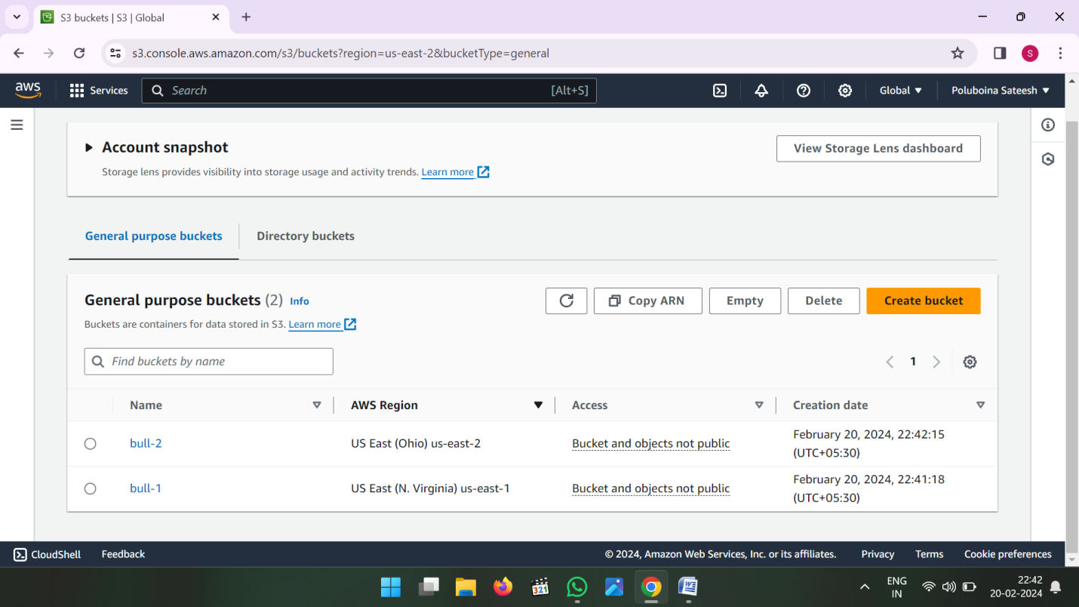

* Now go to first bucket and click on upload

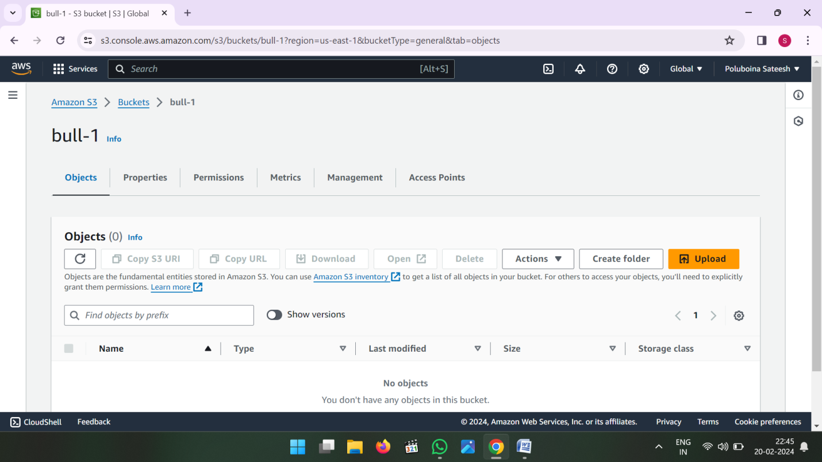

* Then Add Files and Add Folders then upload

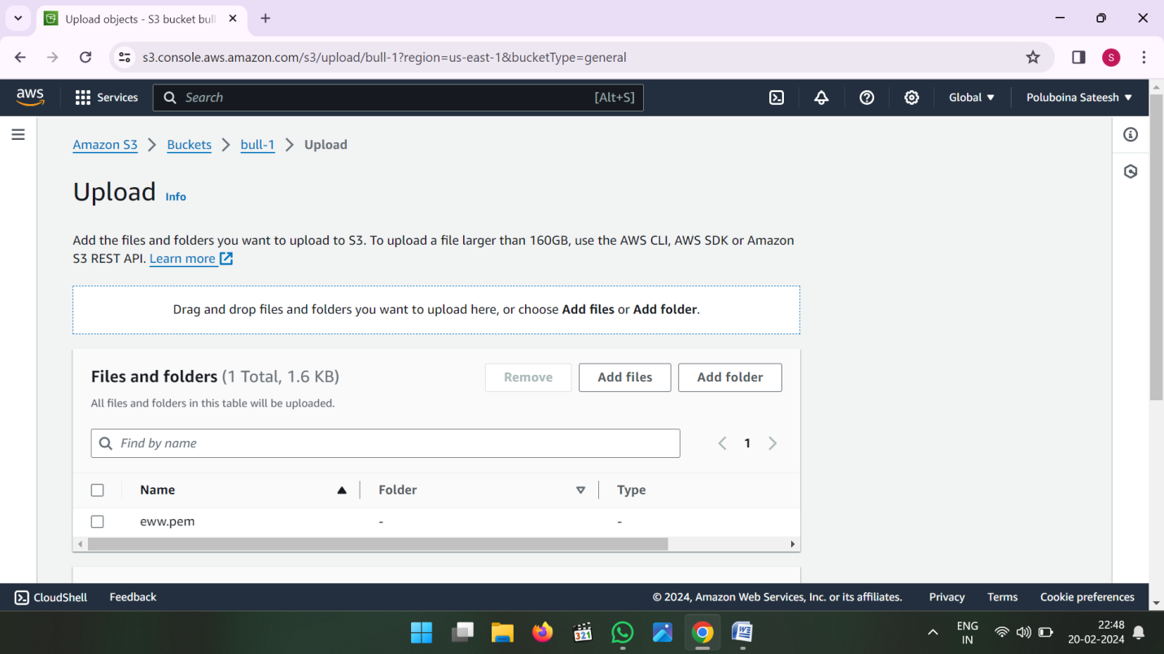

* Click on Upload

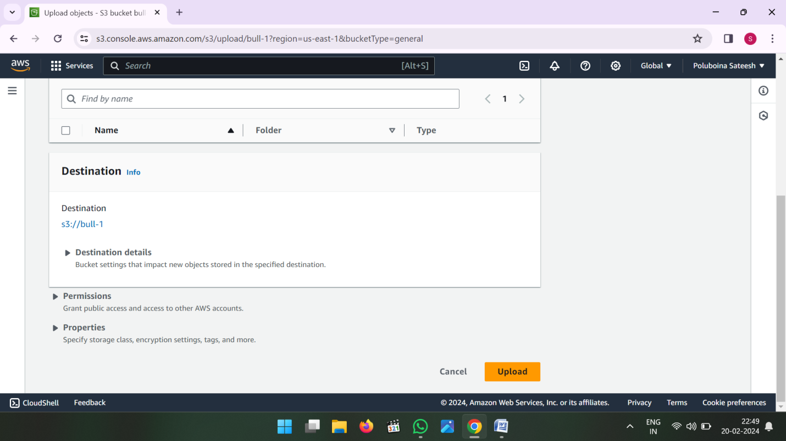

* Uploading Files and Folders

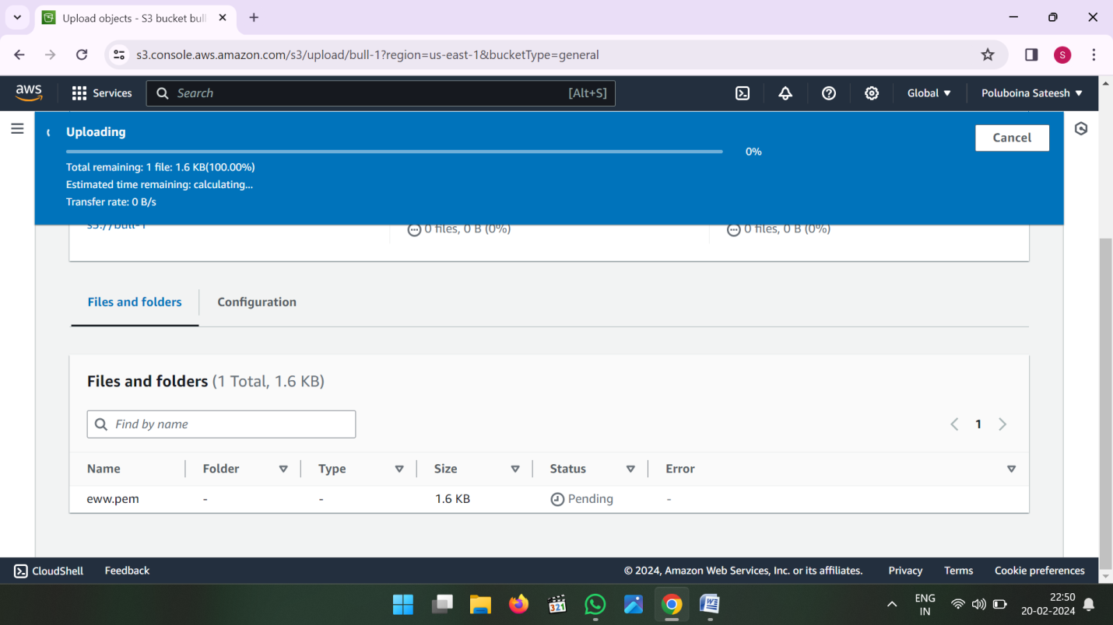

* Now go to Management in first bucket (or) Source Bucket

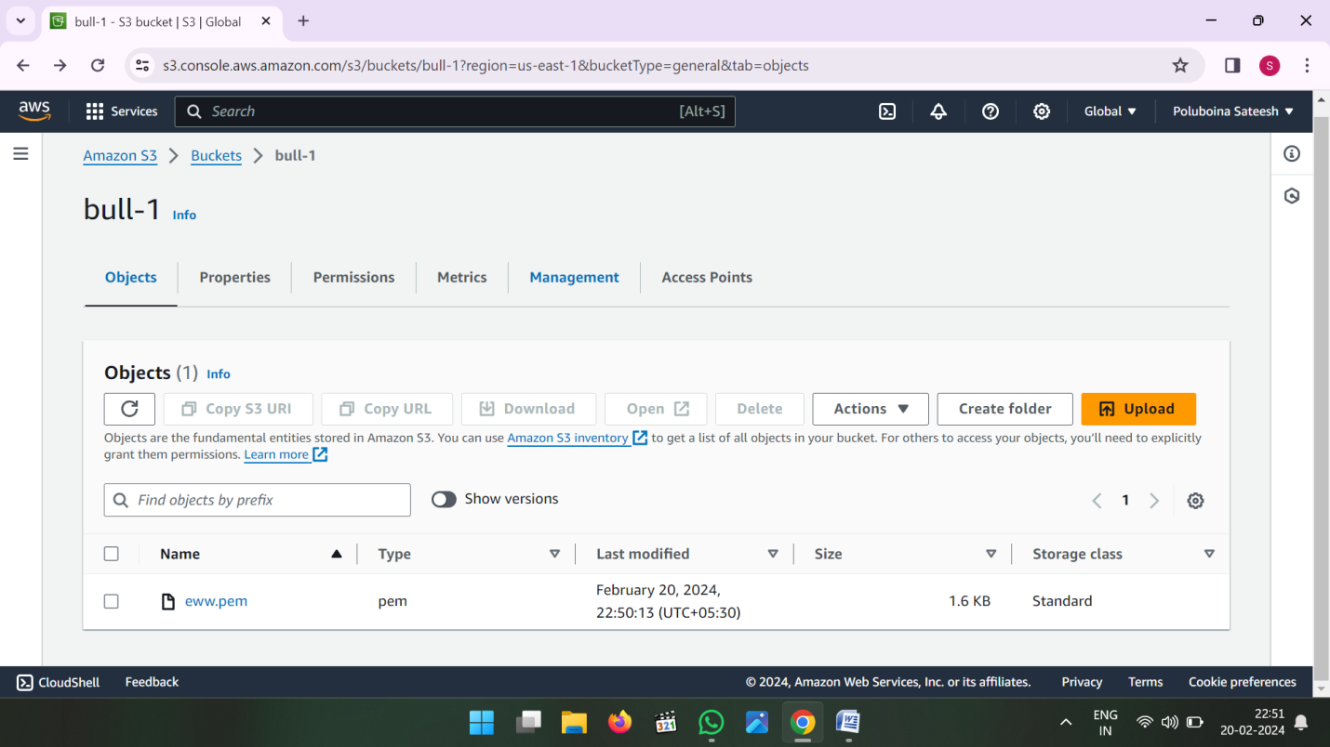

* In Management Console click on create Replication Rule

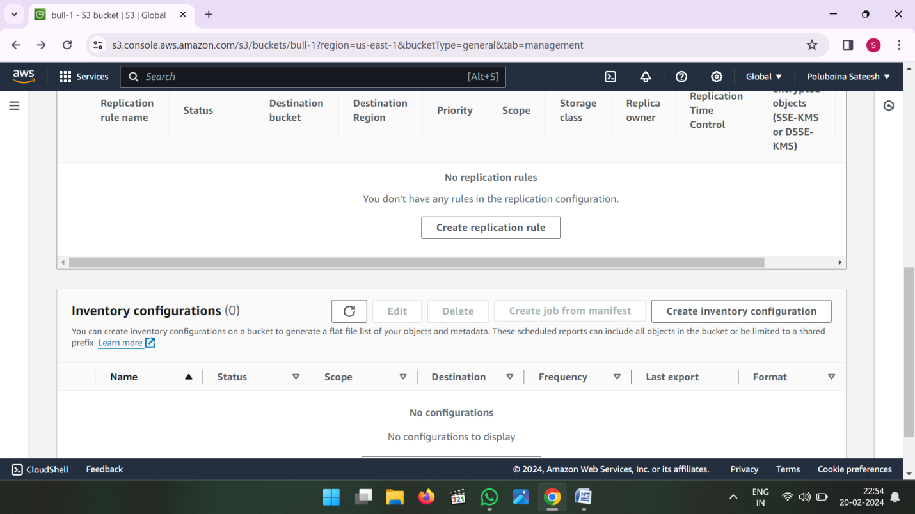

* Enter Replication rule name

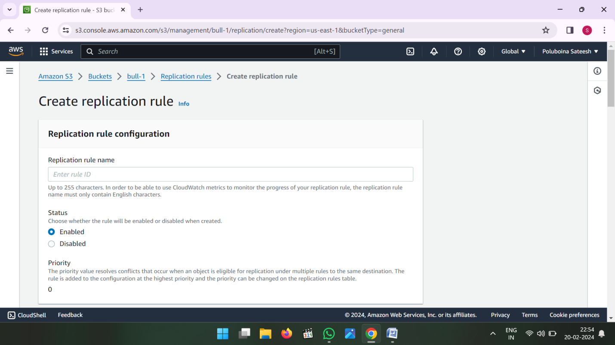

* Click on Apply to all objects in he bucket

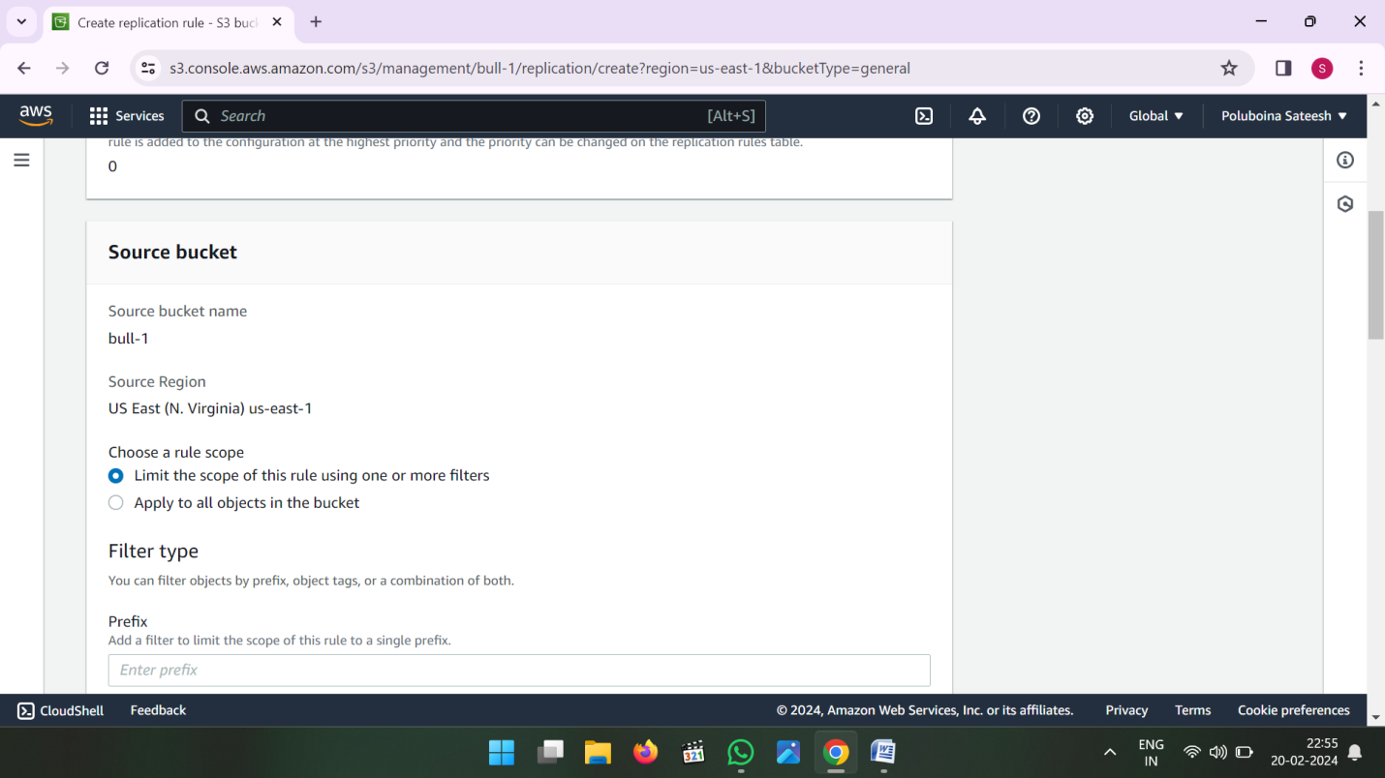

* Now Choose Destination where ever you want to see the data

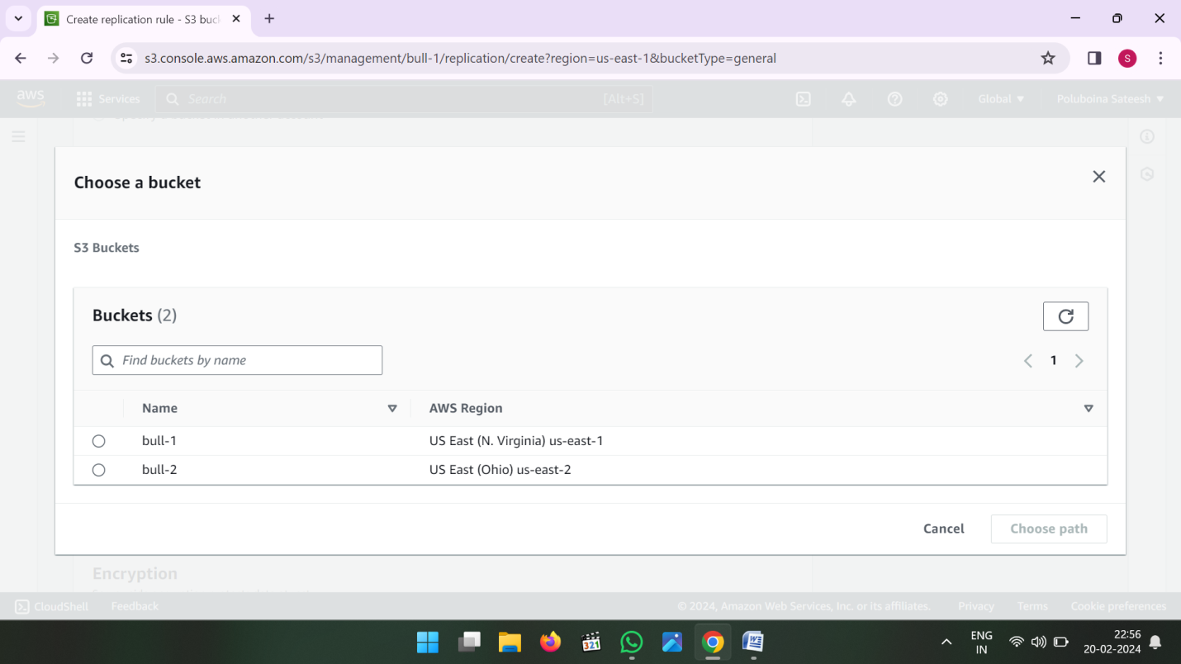

* Choose a bucket in this account

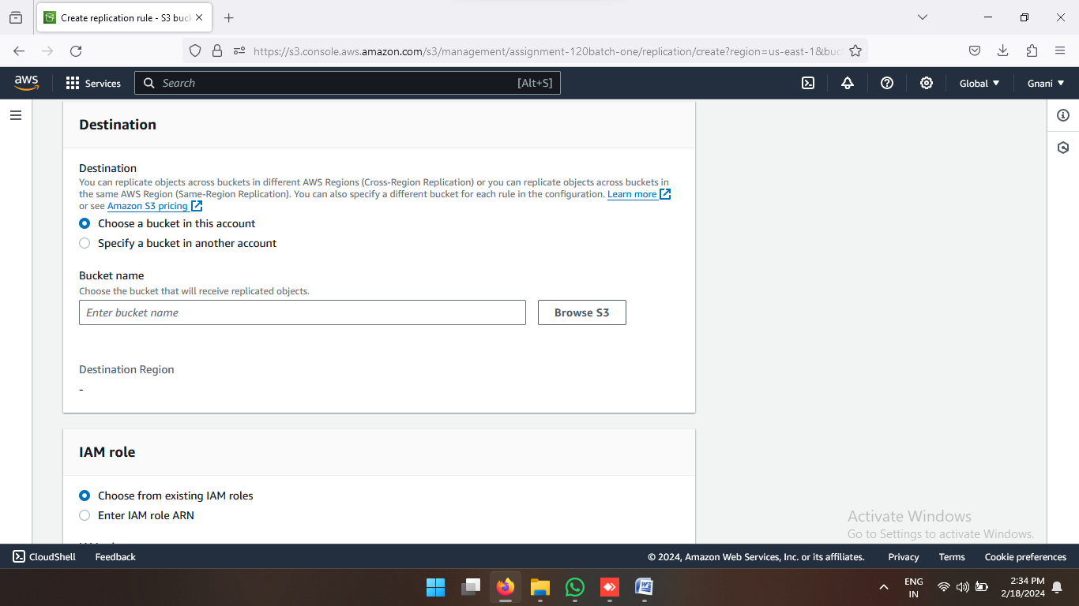

* Select another region Bucket (or) Where ever you want to see the data that bucket select and click on choose path

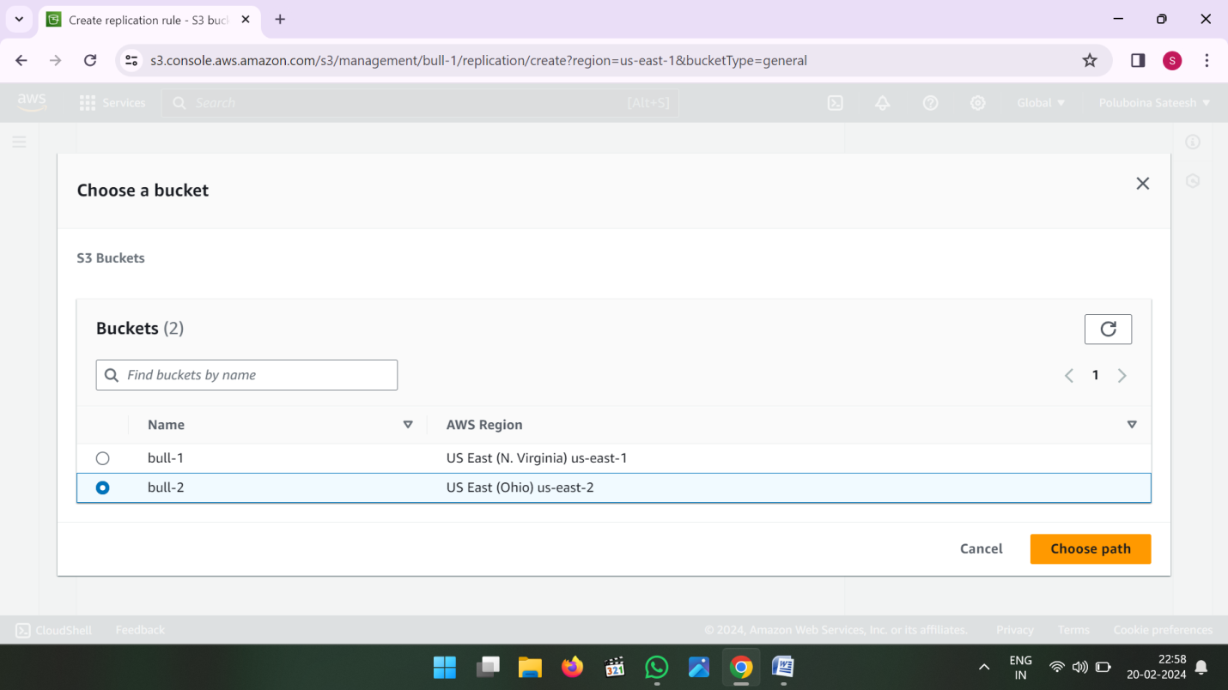

* Now choose from existing IAM roles

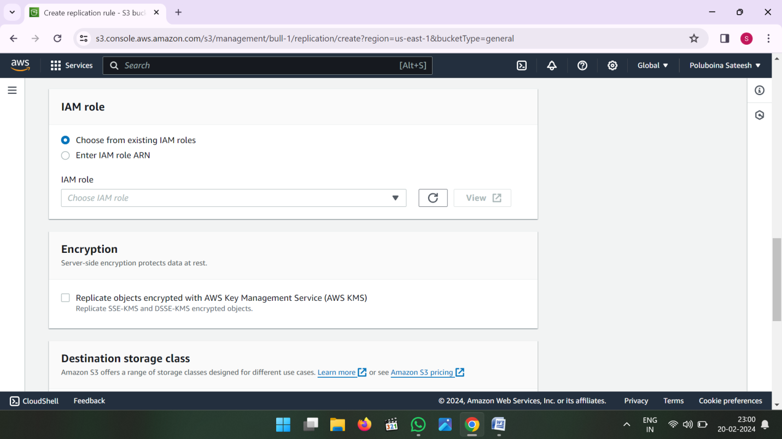

* Select Drop down Create a new role

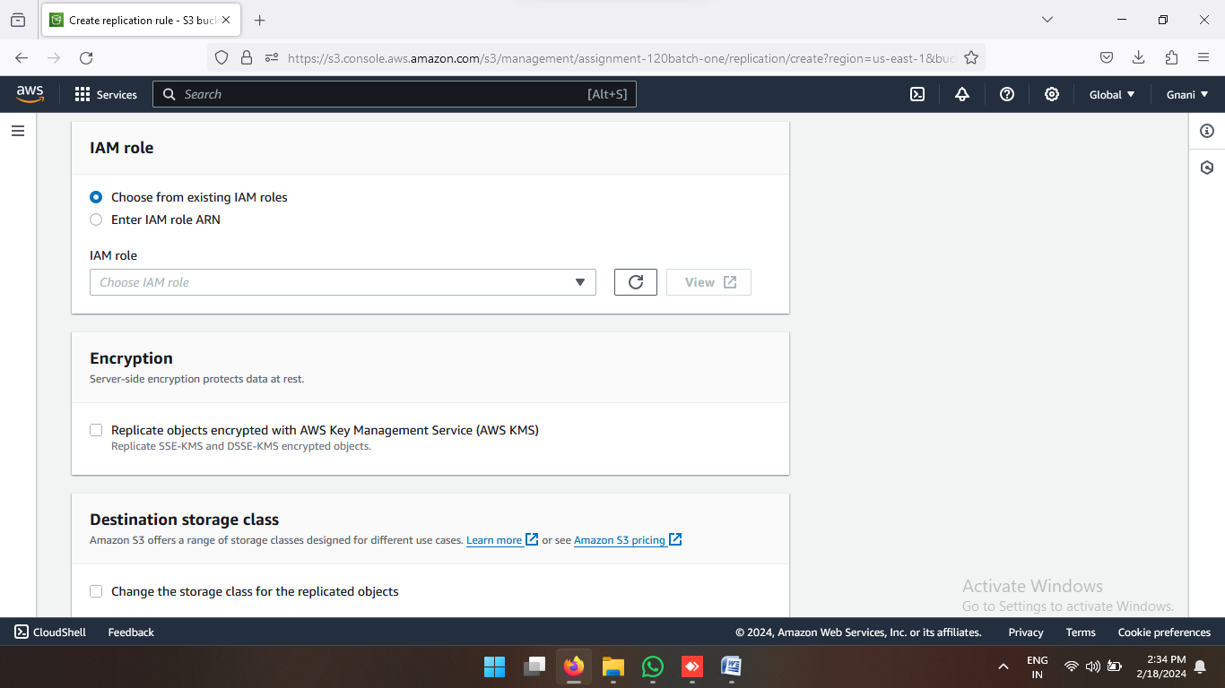

* Then Save the Replication Rule

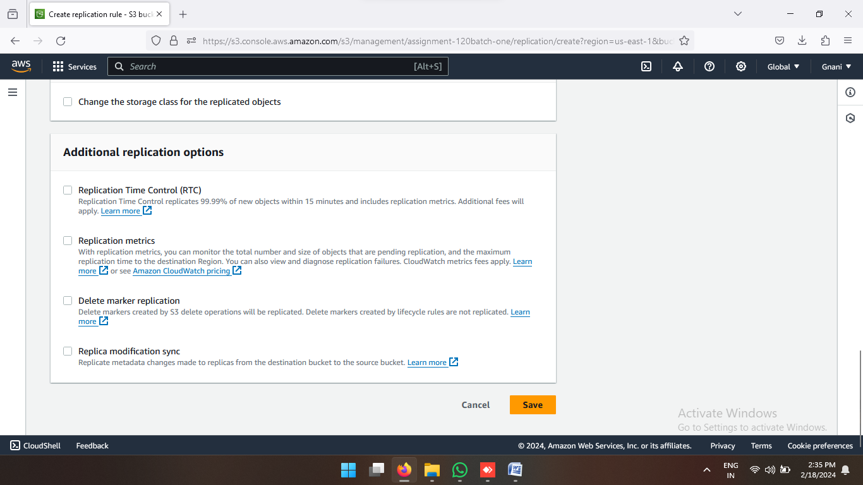

* Now if you want see the existing data then click on Yes
* If you don’t want to see the existing data then click on No then submit

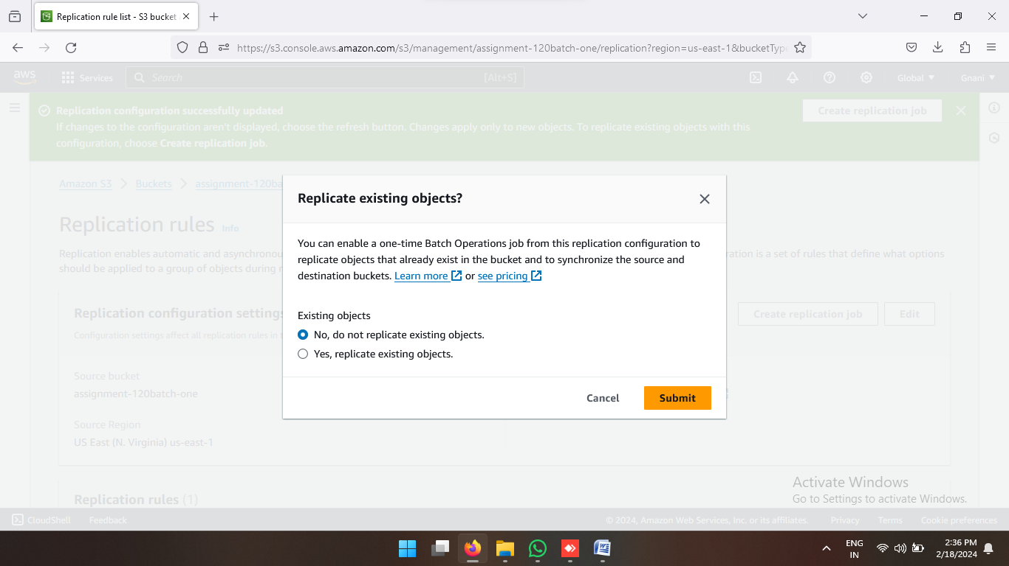

* If You Click yes then choose the destination path again and click on save button

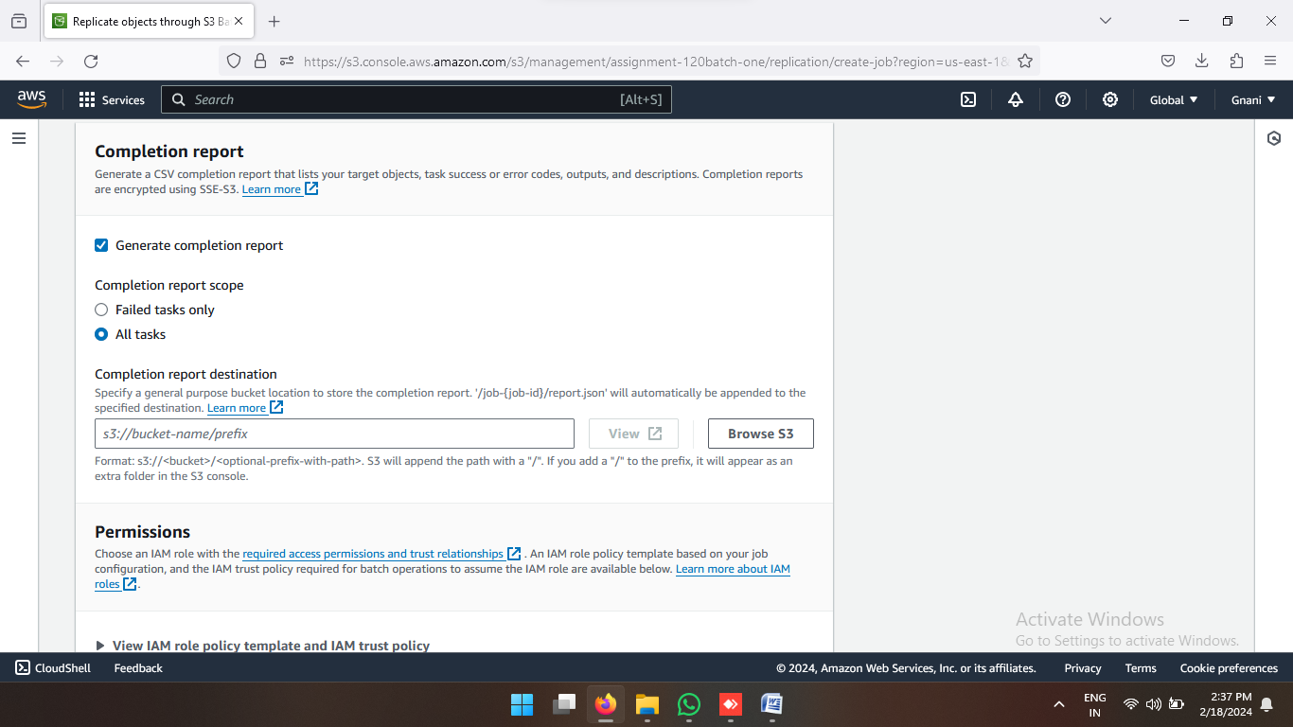

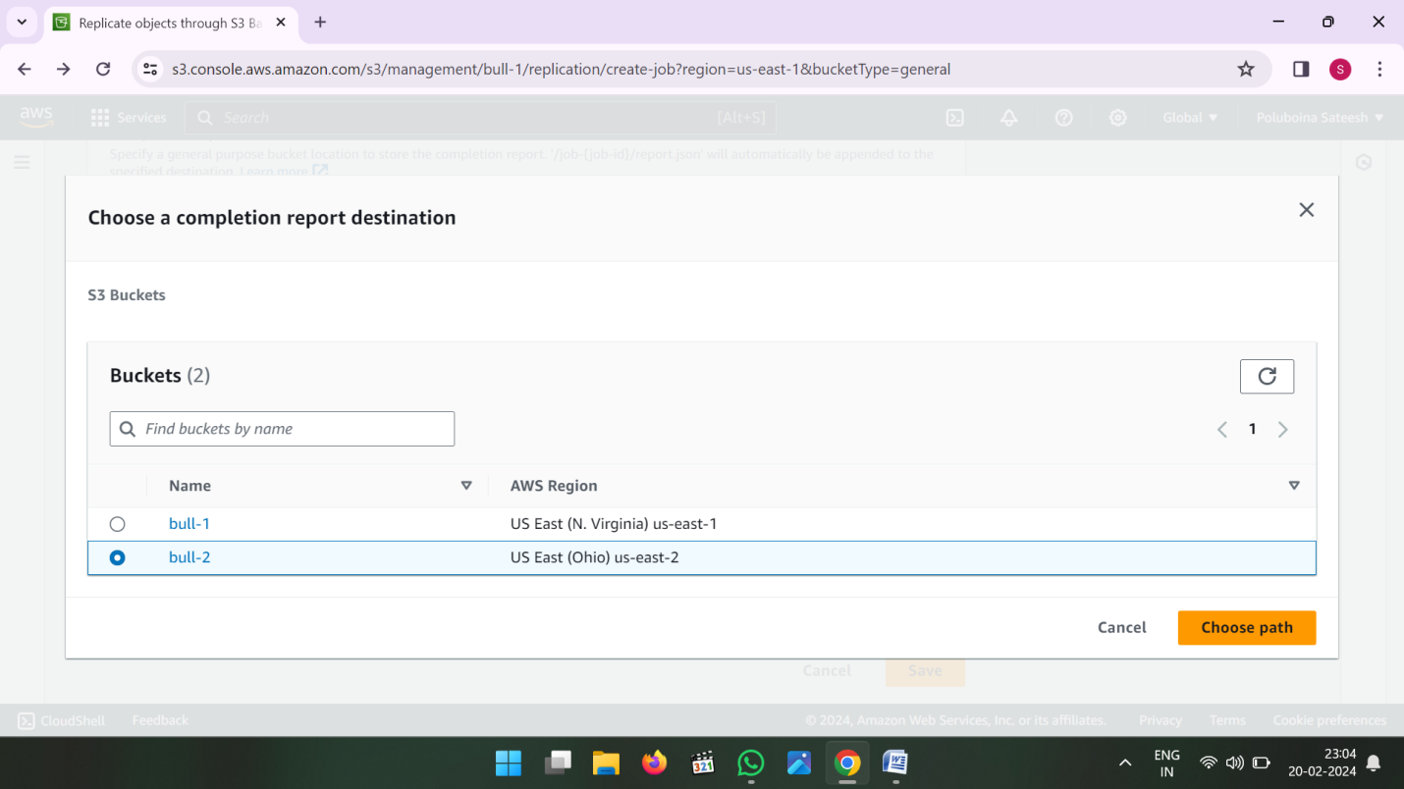

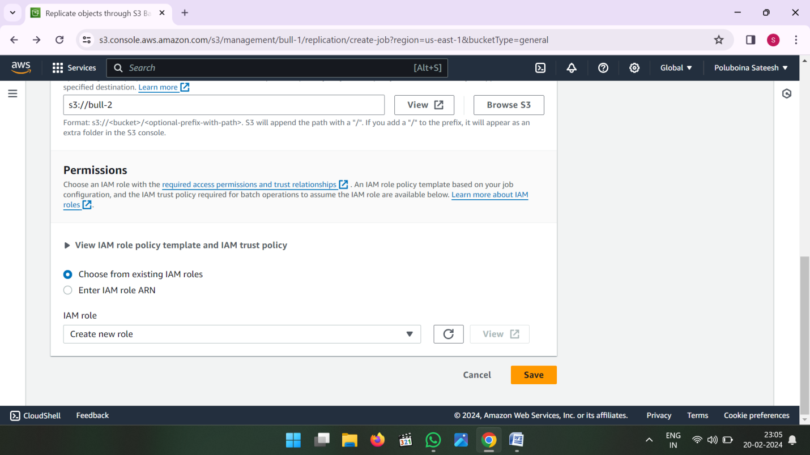

* After Save Button Click then one batch Operation Created that status is showing Preparing.
* Status is changed active then we can see the data into the destination bucket.

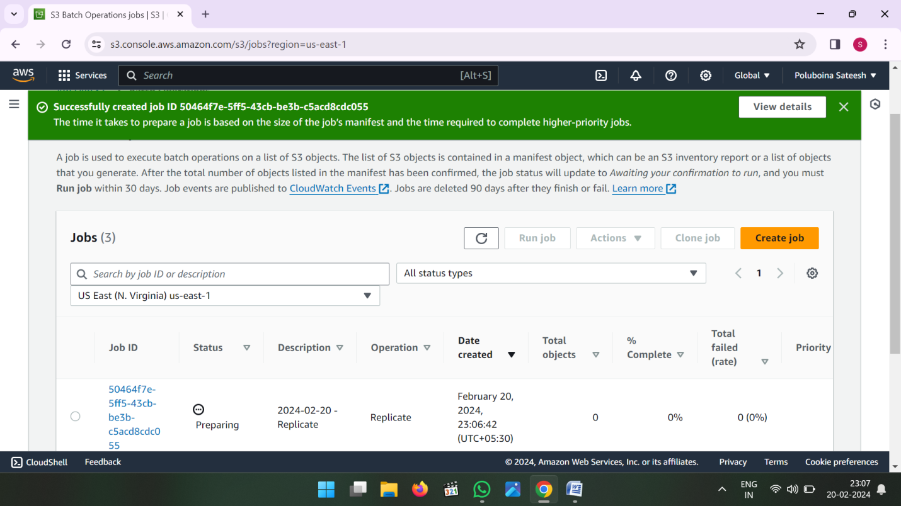

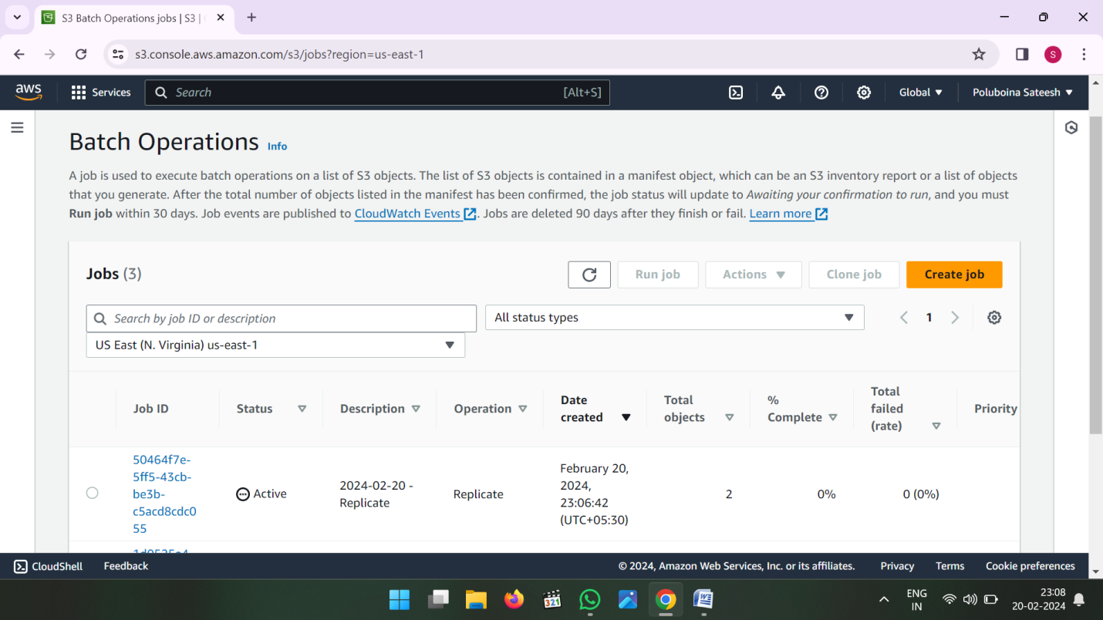

* Whenever Batch Operation Active go to Destination Bucket and see the data.

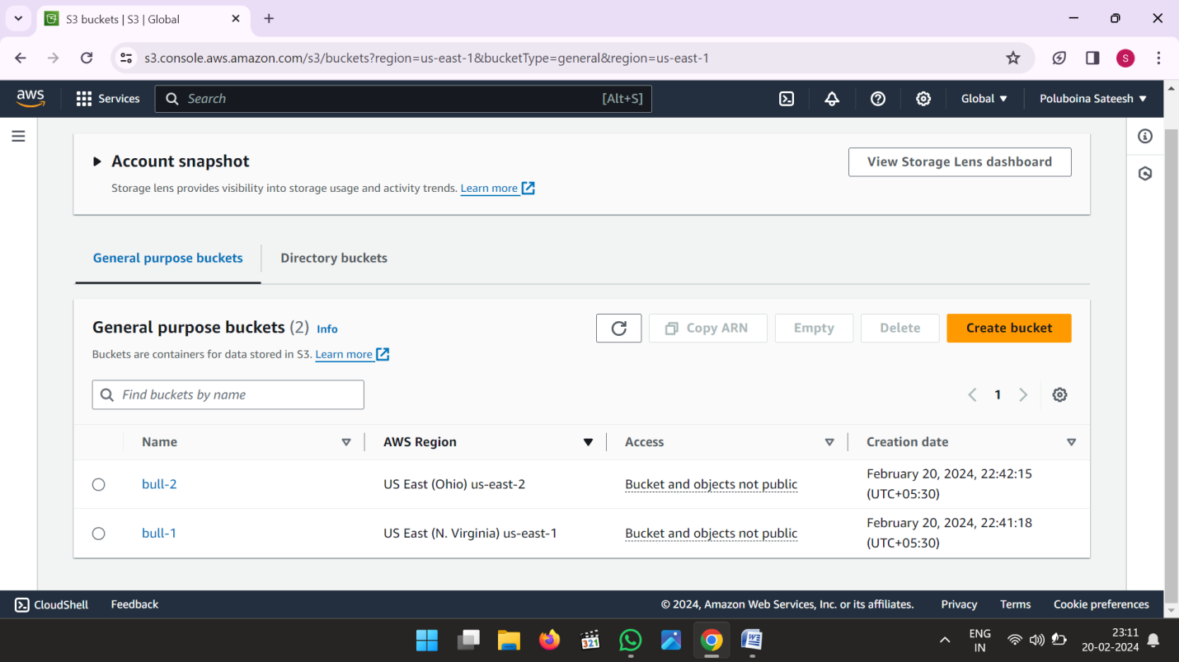

* Now See the data in Destination Bucket.

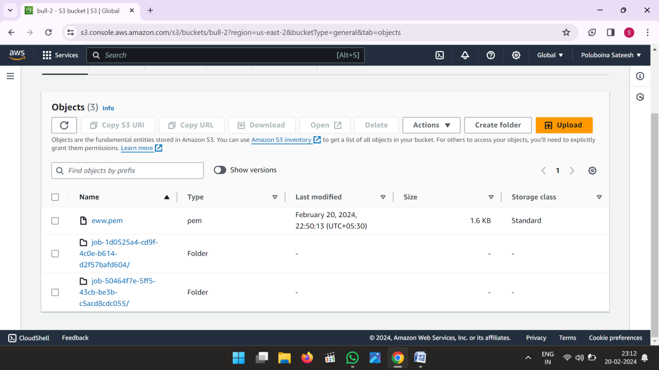

**V.SHIVA SAI**

**Shivasainetha313@gmail.com**

**Batch No : 120 – 5PM**

**Date : 20-02-2024.**

**THANK YOU**